2025 Campaign Newsletter & Intranet Templates

Newsletter
Impact Messaging
Thank You Messaging
Intranet
Impact Messaging
Thank You Messaging
NEWSLETTER  Impact Messaging | With rising challenges and more people seeking support for the first time, now is the time to rally around our neighbours in Halton and Hamilton.  Please share this this message from your United Way:  Hello <Org Name>,  Thanks to your support of <OrgName>’s United Way campaign, local people like Montanna are finding hope and building better futures.  At 18, pregnant and alone, Montanna had nowhere to go. With no family or shelter options, she was referred to a United Way-supported Residential Program. It became her lifeline.  With guidance and compassion, Montanna gained the skills and confidence to care for her newborn son, Cain. She went on to graduate high school, earn her driver’s license, and get accepted into college, milestones she never thought possible.  The program not only gave her stability and support, but a new path to thriving as a mother and student.  “United Way didn’t just help me survive, they helped me create a future for me and my son.”  Montanna is just one of more than 226,500 individuals and families whose lives were changed last year because of people like you.  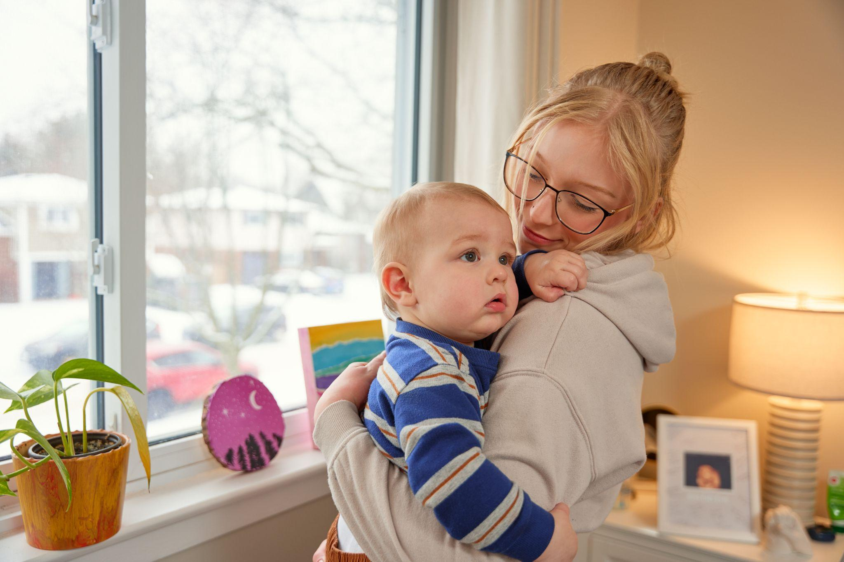  By supporting United Way, you’re helping keep our community’s safety net strong for those facing poverty, crisis, and isolation.  United in ACTION, we can ensure no one is left behind. Please visit uwhh.ca to learn more.  P.S. With a gift of $100+/ month, or $1,200+ annually, you can become a United Way Leadership donor. You'll drive lasting change and support vital programs that families, seniors, and children rely on. Step up, and lead with purpose. Come join a powerful local network, today!
Thank You Messaging | You for Powering Change Across Halton & Hamilton!: Message of Gratitude from Your United Way:  Hello <Org Name>,  Thank you for standing with United Way Halton & Hamilton this year!  Because of your generosity, more than 226,500+ individuals and families in our region are getting the support they need to build brighter, more stable futures.  From safe shelter to mental health care, food security to youth programs, your commitment fuels real impact across our communities.  Stay tuned for exciting updates throughout the 2025-26 campaign! We can’t wait to share what your support makes possible.

INTRANET  Impact Messaging | Thanks to your support of <OrgName>’s United Way campaign, local people like Montanna are finding hope and building better futures.  At 18, pregnant and alone, Montanna had nowhere to go. With no family or shelter options, she was referred to a United Way-supported Residential Program. It became her lifeline.  With guidance and compassion, Montanna gained the skills and confidence to care for her newborn son, Cain. She went on to graduate high school, earn her driver’s license, and get accepted into college, milestones she never thought possible.  The program not only gave her stability and support, but a new path to thriving as a mother and student.  Montanna is just one of more than 226,500+ individuals and families whose lives were changed last year because of people like you.  By supporting United Way, you’re helping keep our community’s safety net strong for those facing poverty, crisis, and isolation.  United in ACTION, we can ensure no one is left behind. Please visit uwhh.ca to learn more.  P.S. With a gift of $100 or more each month, or $1,200+ annually, you can become a United Way Leadership donor. You'll drive lasting change and support vital programs that families, seniors, and children rely on. Step up, and lead with purpose. Come join a powerful local network, today!
Thank You Messaging | You for Powering Change Across Halton & Hamilton! Here is a special note from your United Way:  Your support of United Way Halton & Hamilton is helping fuel real, lasting impact. Because of you, thousands of individuals and families are accessing the vital programs, resources, and support they need to build brighter futures.  In times of challenge, you’ve shown what it means to be united in ACTION, and we’re just getting started.  Stay tuned for updates throughout the 2025–26 campaign.

Link to Montanna’s Photo: https://drive.google.com/file/d/1Q1-JD_4NIEVVMqQmJqVahsj9WgAZCJpz/view?usp=sharing

